# logonewCOMSATS University Islamabad

**Abbottabad Campus**

**Department of Computer Science**

Lab Sessional # 1

Class: **BSE-7A**  Date: **19 October 2020**

Subject: **HCI**  Instructor: **Humaira Jabeen**

Total Time Allowed: Max Marks: 2**0**

Name: Ehsanullah Registration # FA17-BSE-024

**HOME PAFE Screen shots:**

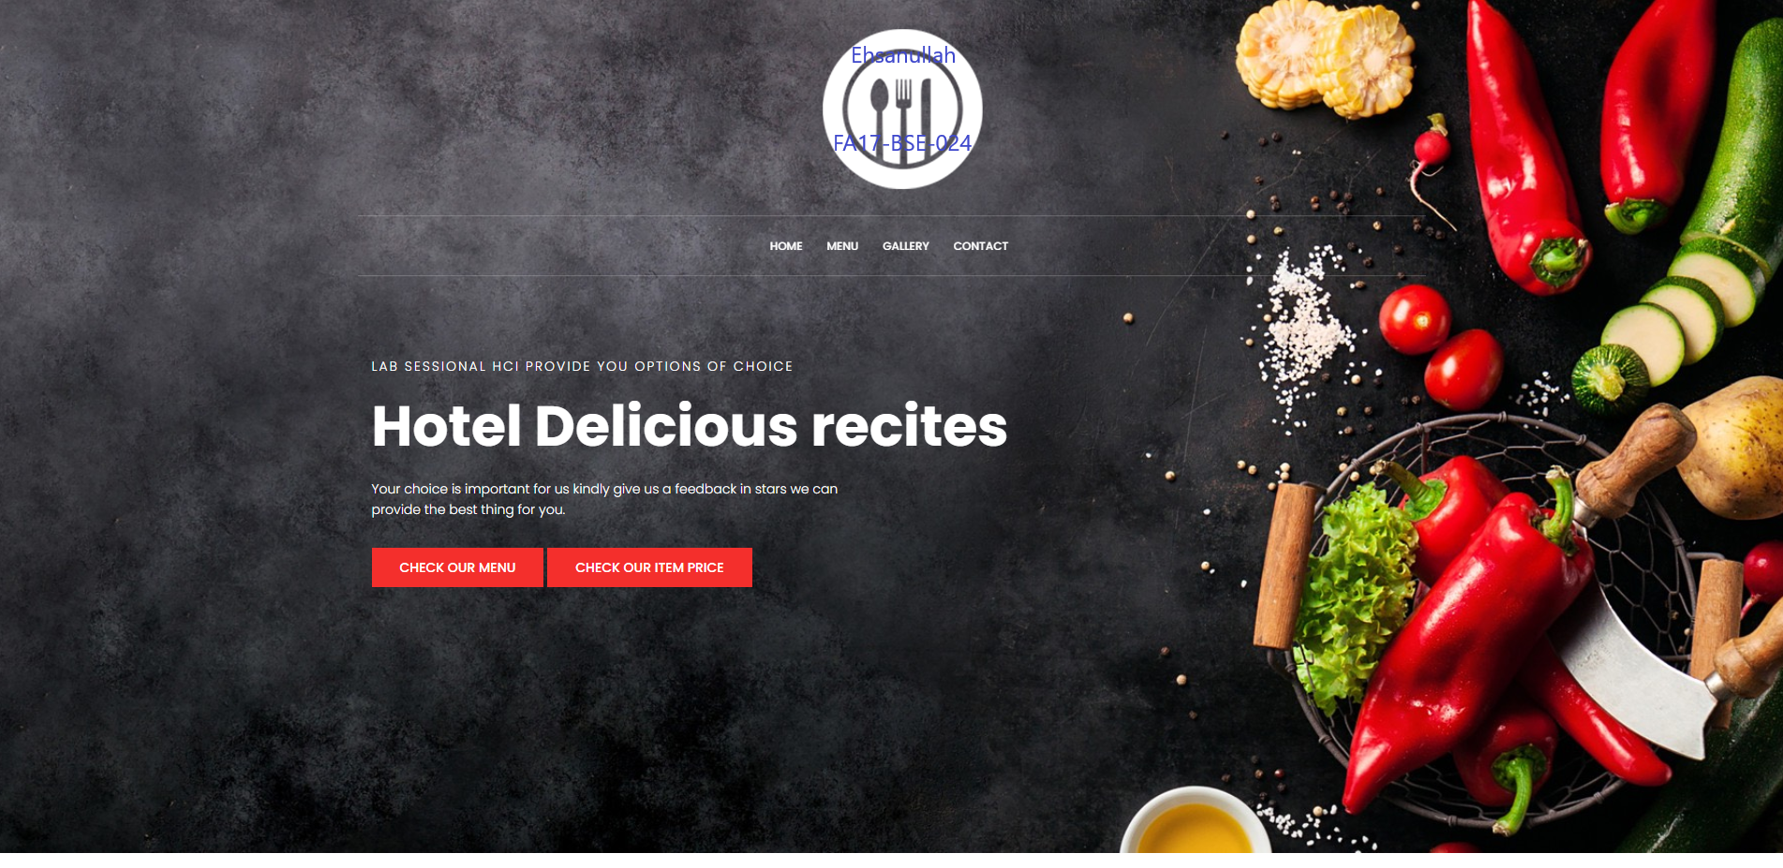

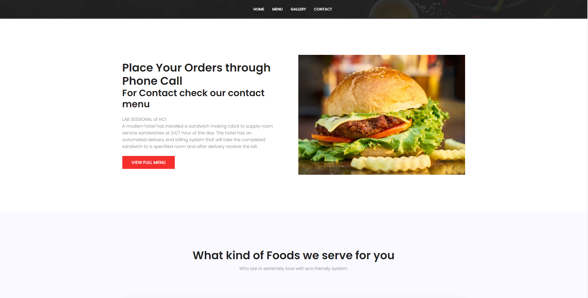

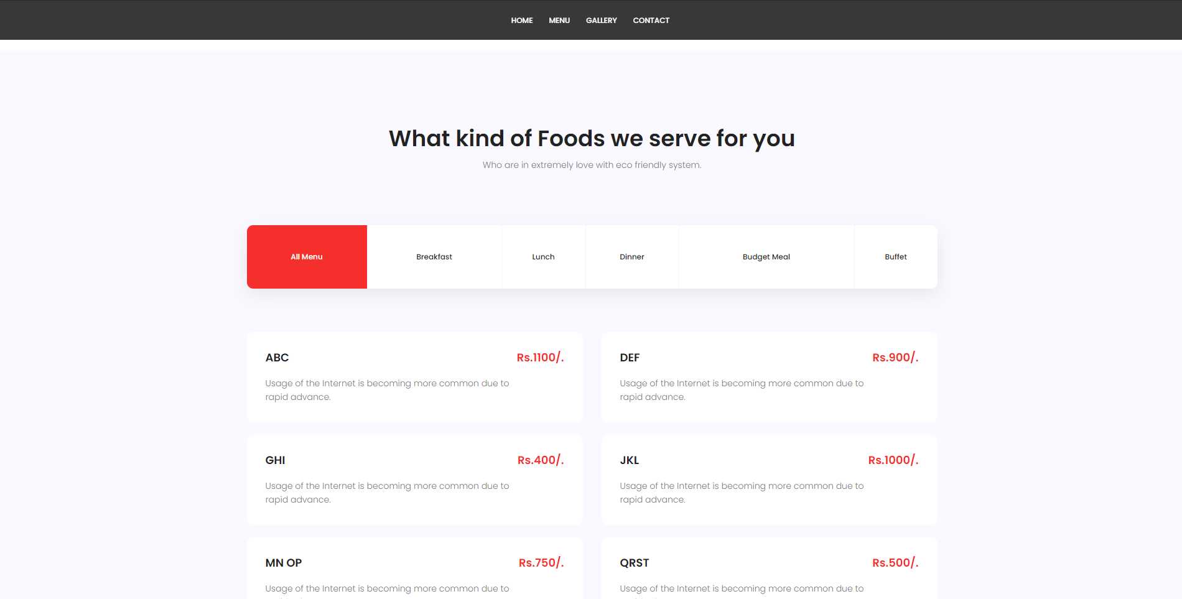

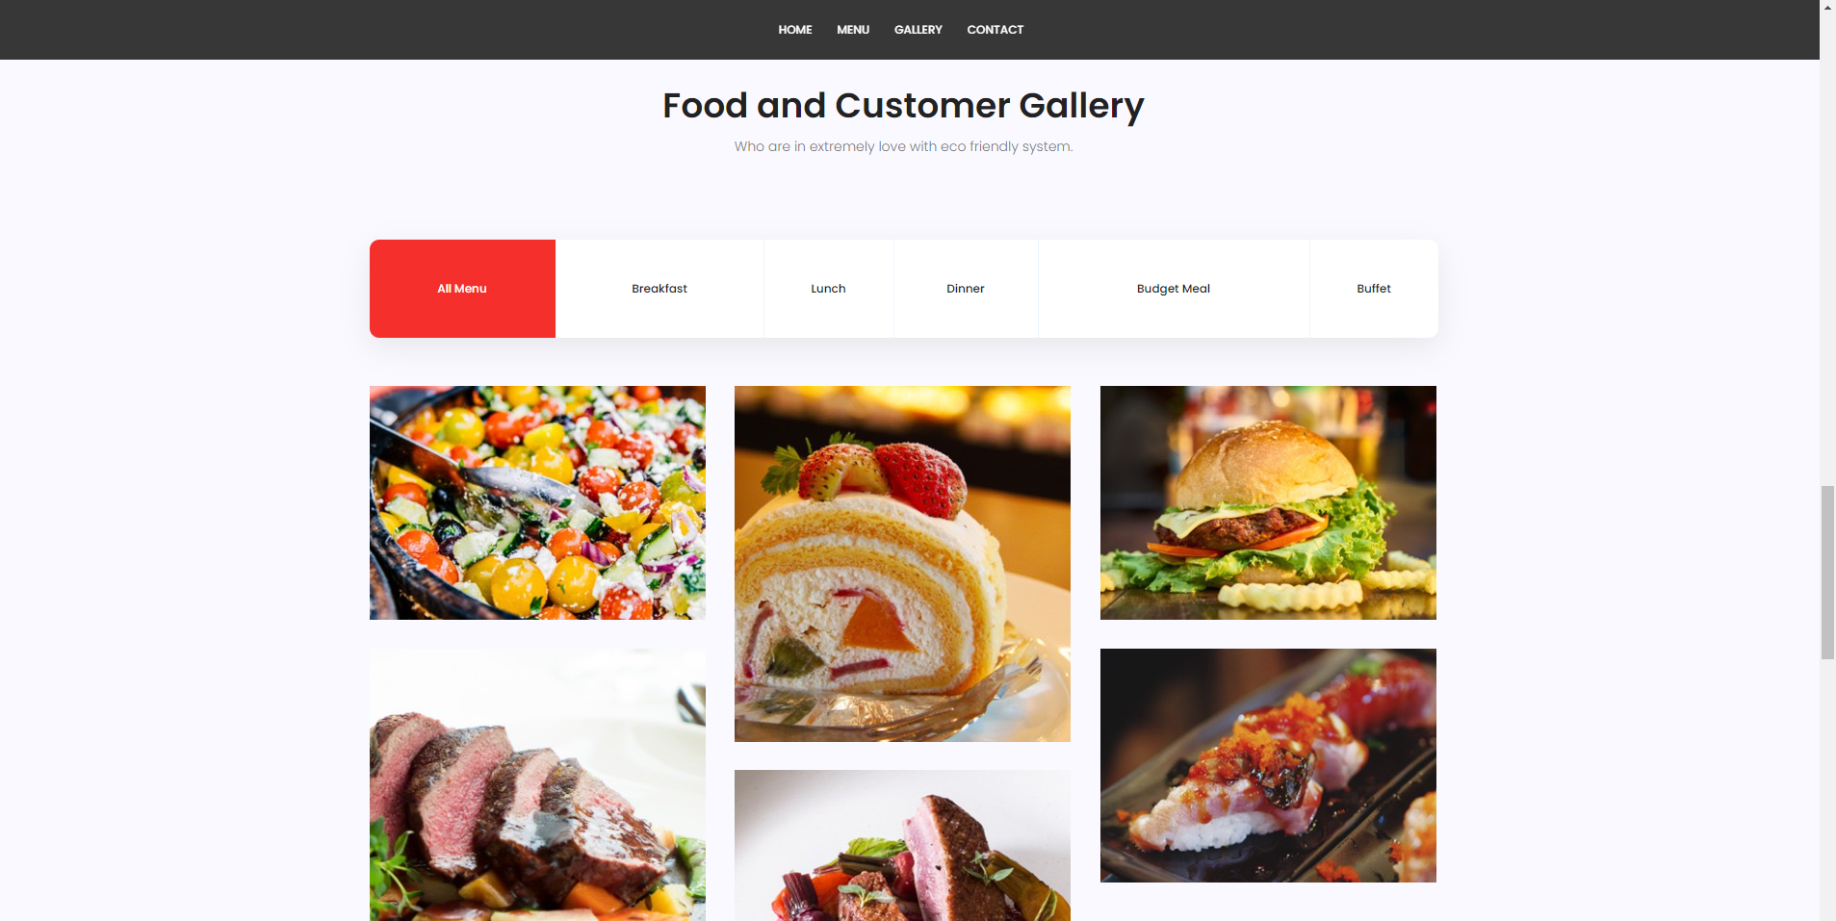

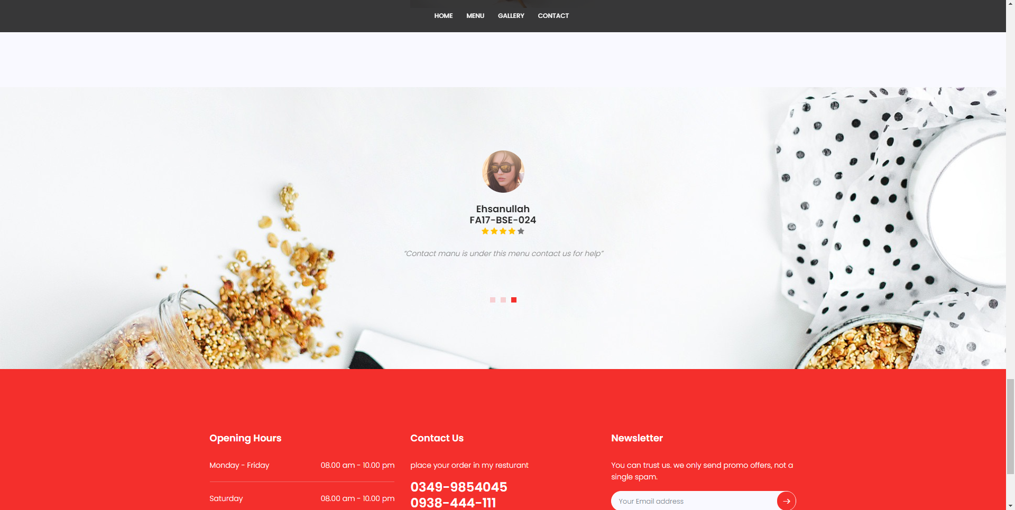

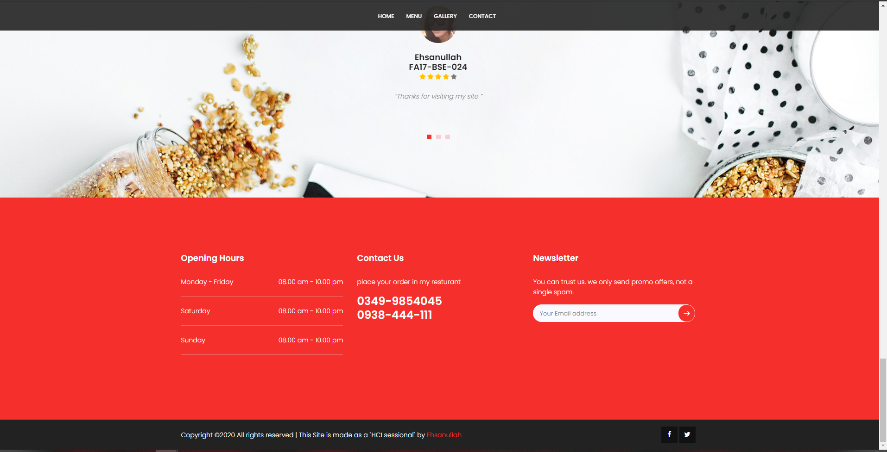

**Menu Page Screen Shots:**

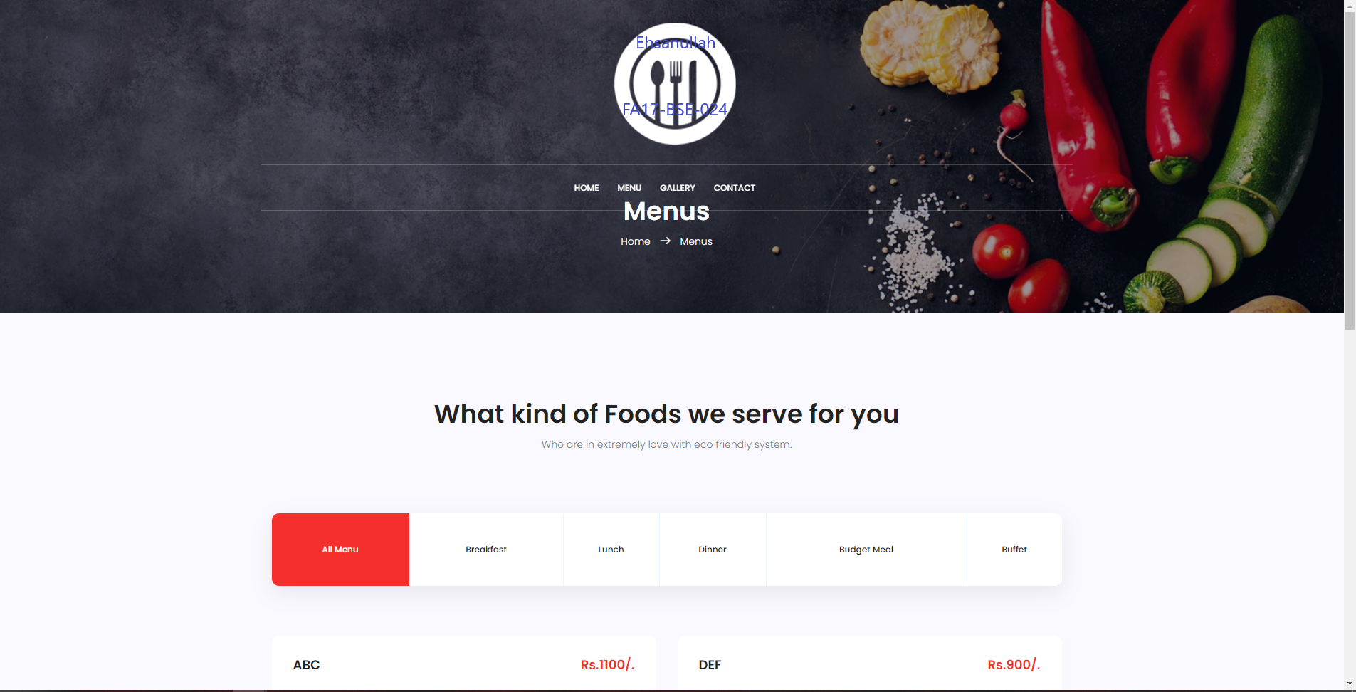

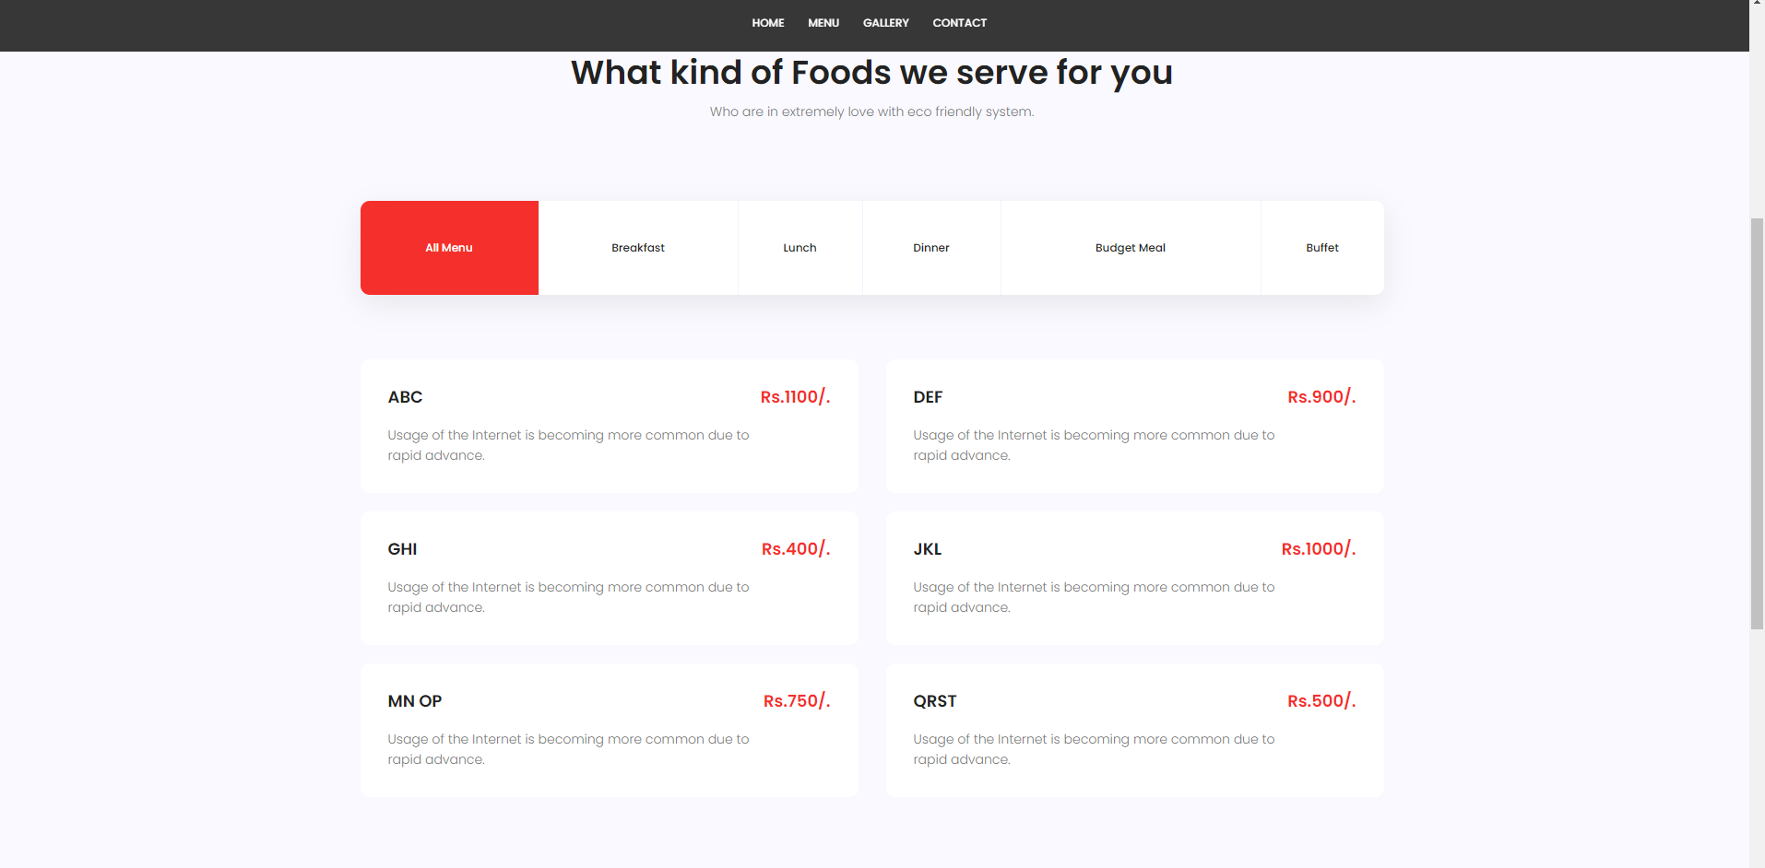

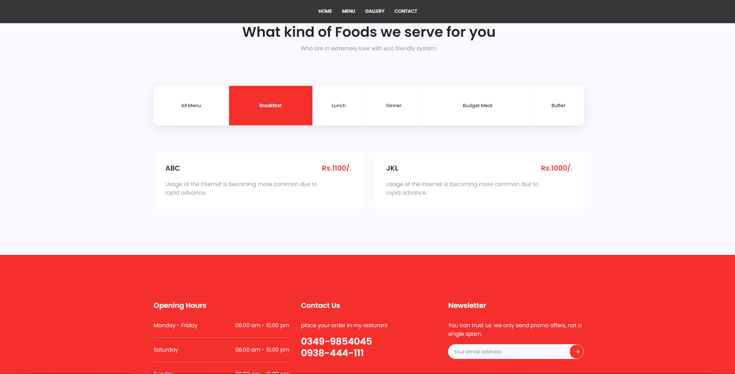

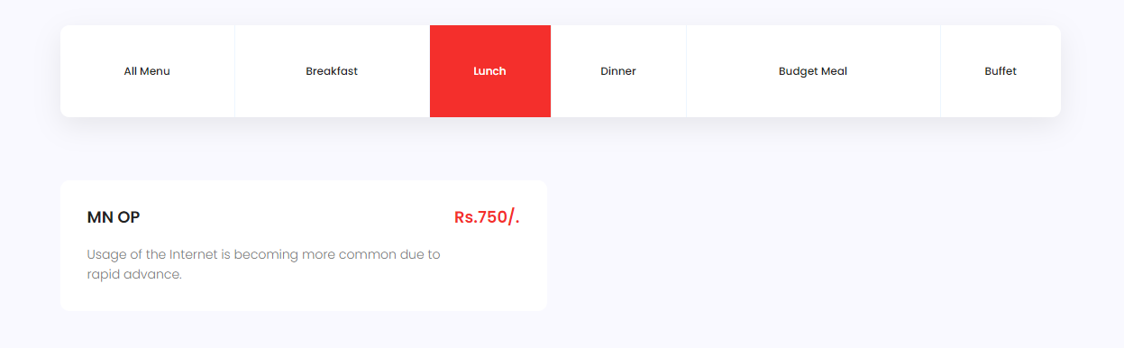

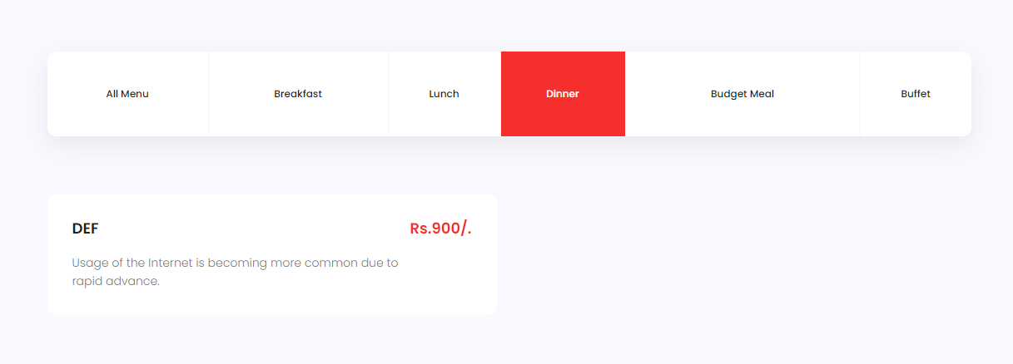

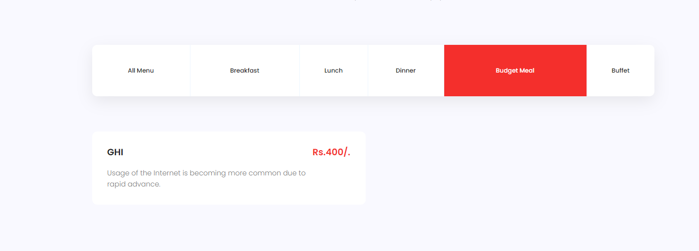

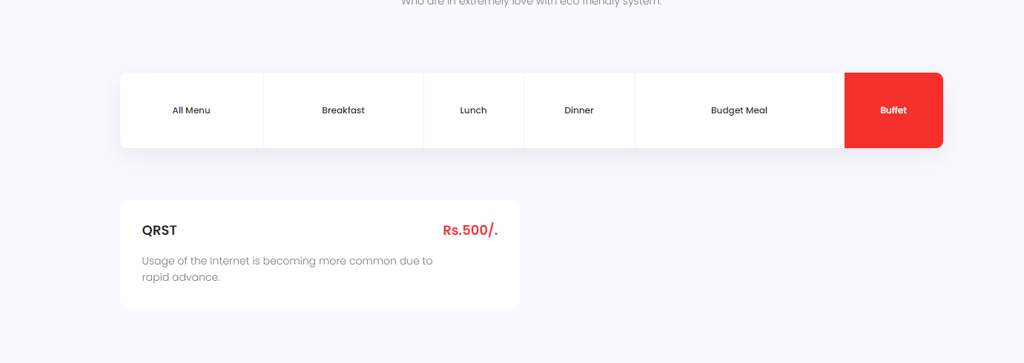

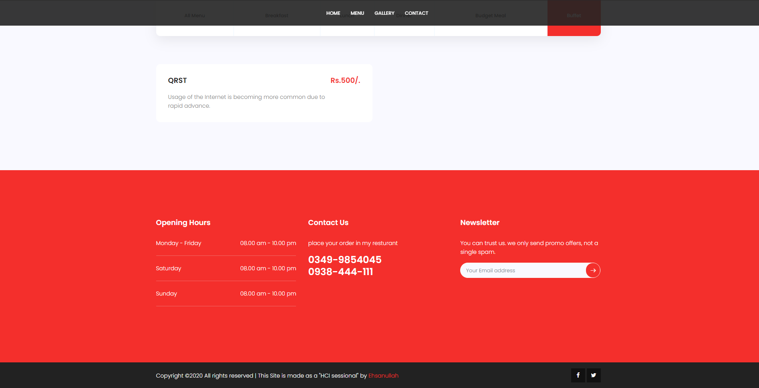

**GALLERY Page Screen Shots:**

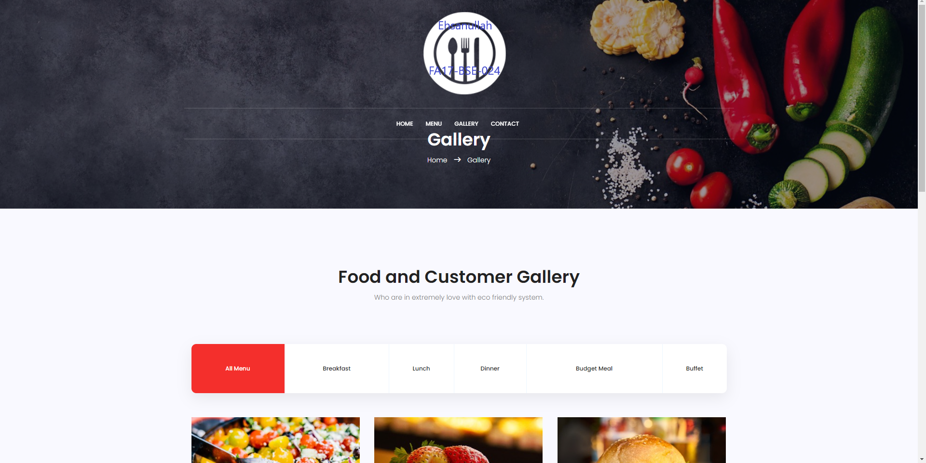

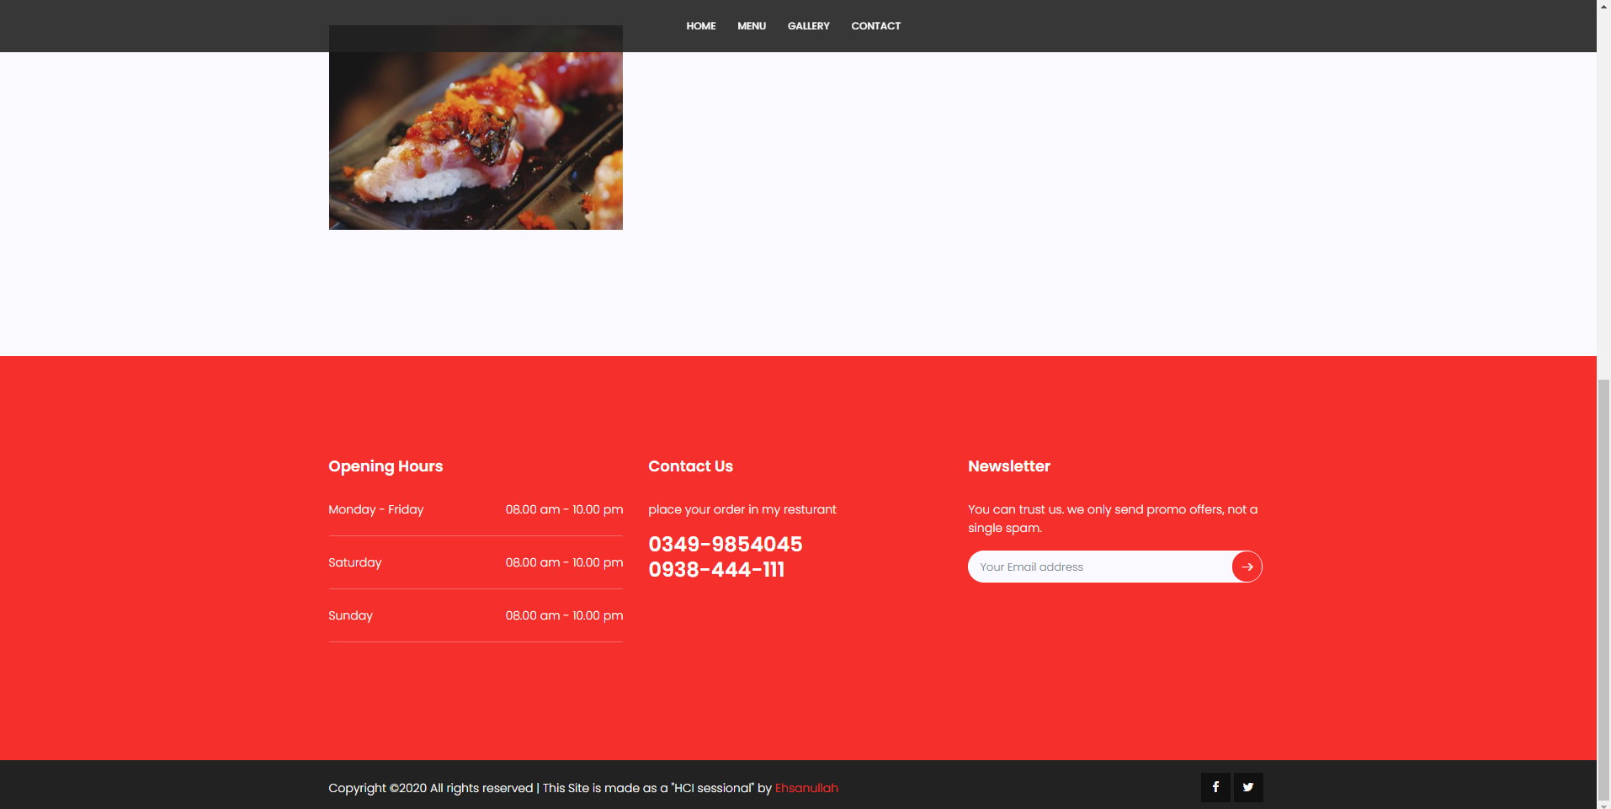

**CONTACT PAGE Screen Shots:**

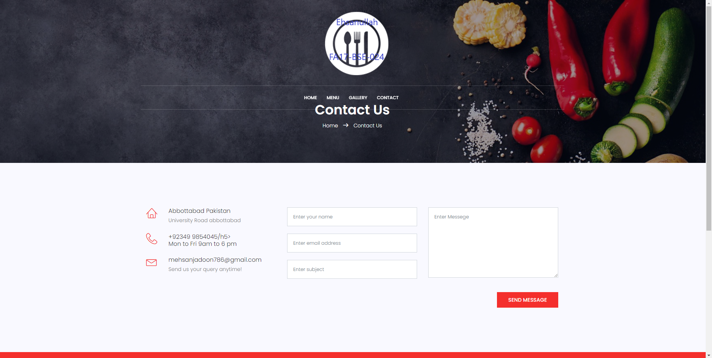

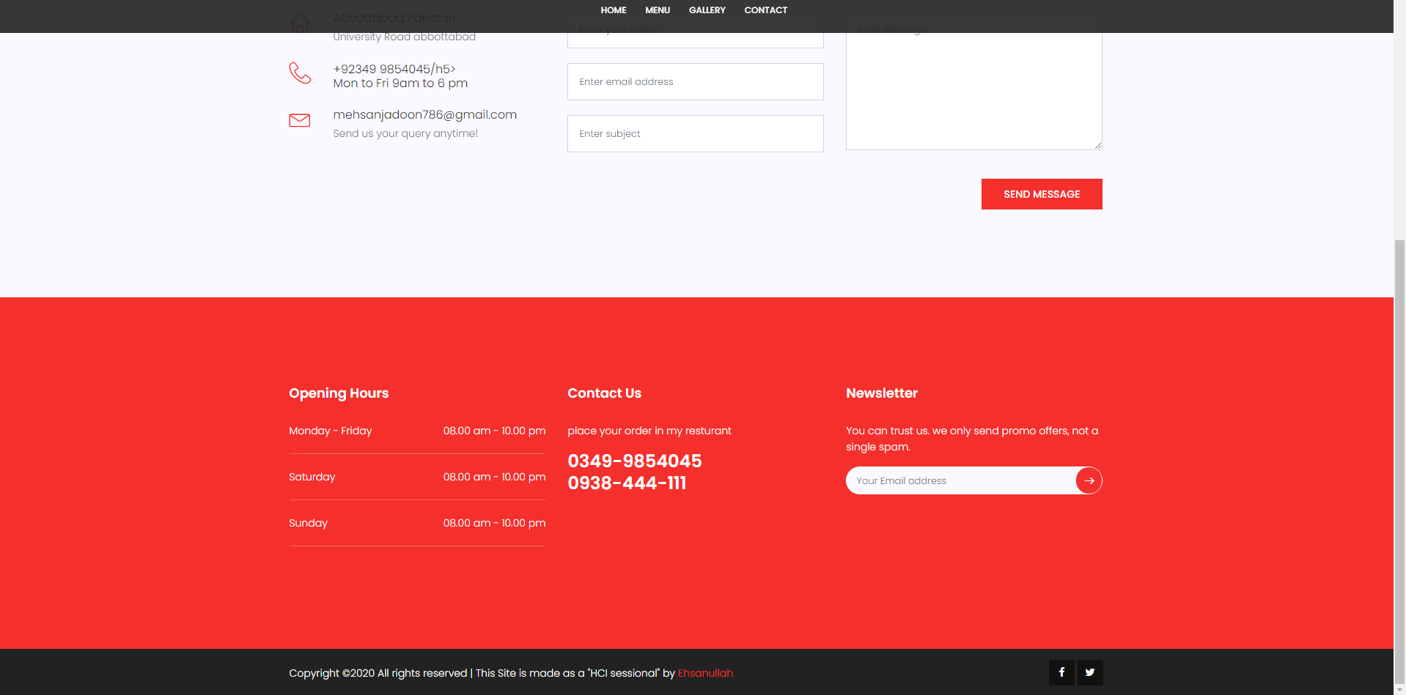

**END:**

**REF : I can get help from my Ex-Project of 4th Semester in web Designing which is online blood donation system**

**And all the Html files are uploaded on GitHub as well here in this folder.**